**Strategic and Predictive Reporting & Analytics on IT Data (Numerify)**

**New Insight Business Requirements Document version 3 - 2020**

{South Korea/ Privacy}

Prepared by: {Alessio Gatti}

Consulted by: {Tanja Wojdyno}

{June 8th 2020}

**Purpose**

This document is designed for new initiatives to get and assessment of Numerify solution fit, complexity and effort, as early as possible, to drive a solution implementation with max efficiency.

**Instructions**

Please provide as much information as possible, also information still to be confirmed (mark as “tbc”). We expect that the use case documentation will evolve over time so we will keep version references in the name. Additional detailed requirements will be captured in individual fulfilment request tickets.

# Use Case Summary

Please describe the use case for which you are requesting a dashboard. Specifically, we want to understand the business context of the requested insight / use case so that we can better assist in defining these requirements. Please answer the following questions in the description:

* Why are you looking to develop this use case? In July 2020 we will start monitoring Privacy compliance for the Country, so we will need to start loading relevant data from Excel to Numerify.
* What is your current state with managing this use case? At present there is no reporting on compliance as the country is still working on data completion. We would like to switch directly from no tool to Numerify if possible. This is the main driver for the urgency.
* What if any challenges arise from the current state? We may decide to switch to Excel and Power BI, even for a temporary solution, but the cost would be notably bigger and the effort to re-educate user community even worse.
* How will it impact your business operations? The cost would be notably bigger and the effort to re-educate user community even worse.
* What are the organizational goals associated with this use case? Privacy compliance reached in South Korea and under control by FY 20/21
* How are the organizational goals being measured? % compliance over time

## Example Questions:

Please list out several questions you would like to be able to answer by using the dashboard built to this requirement:

* This Dashboard should replicate the CCPA existent one as much as possible/reasonable.

## Business Case/ Value:

How will value be created (e.g. productivity, compliance)? What is the expected value ($)? Compliance and single vision of the data for local business and across jurisdictions for R&D (R&D is already leveraging Europe and CCPA solutions).

## Priorities and timelines:

If this is a larger initiative, do you consider a phased release? Please list the functional milestones. Also note how this could be deployed to user groups in phases. Last but not least, we need to understand if there is any important business dates to be met.

South Korea Privacy systems setup is selected as a model that we want to broadly re-apply all over AMA region. Although there aren’t stringent deadline for South Korea, in the rest of the Region there are imminent (Nigeria) and already expired (Japan, Singapore) deadlines, for which it is important to proof the concept and re-apply quickly what we are piloting in South Korea. Bottom line we need to have South Korea Up, running and adopted in Numerify by no later than August/September 2020.

## Presentation Requirements:

Please provide specific requirements of how you would like answers to the questions above presented to the users in dashboard form.

Refer to CCPA appearance, namely:

* Compliance Cockpit (4 tabs)  
  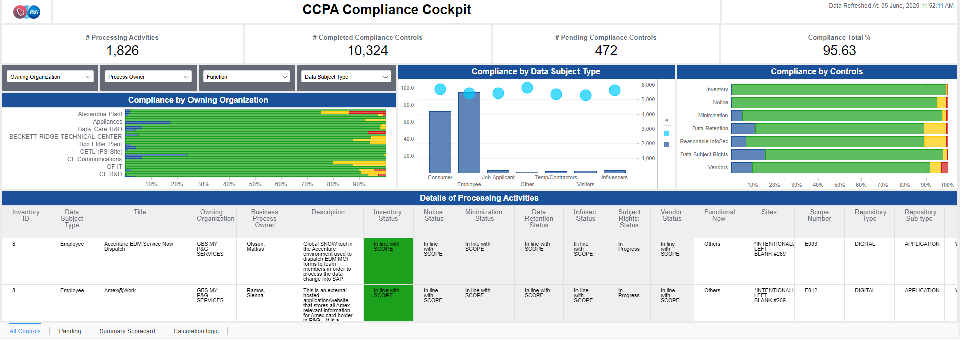
* Data Quality (2 tabs)  
  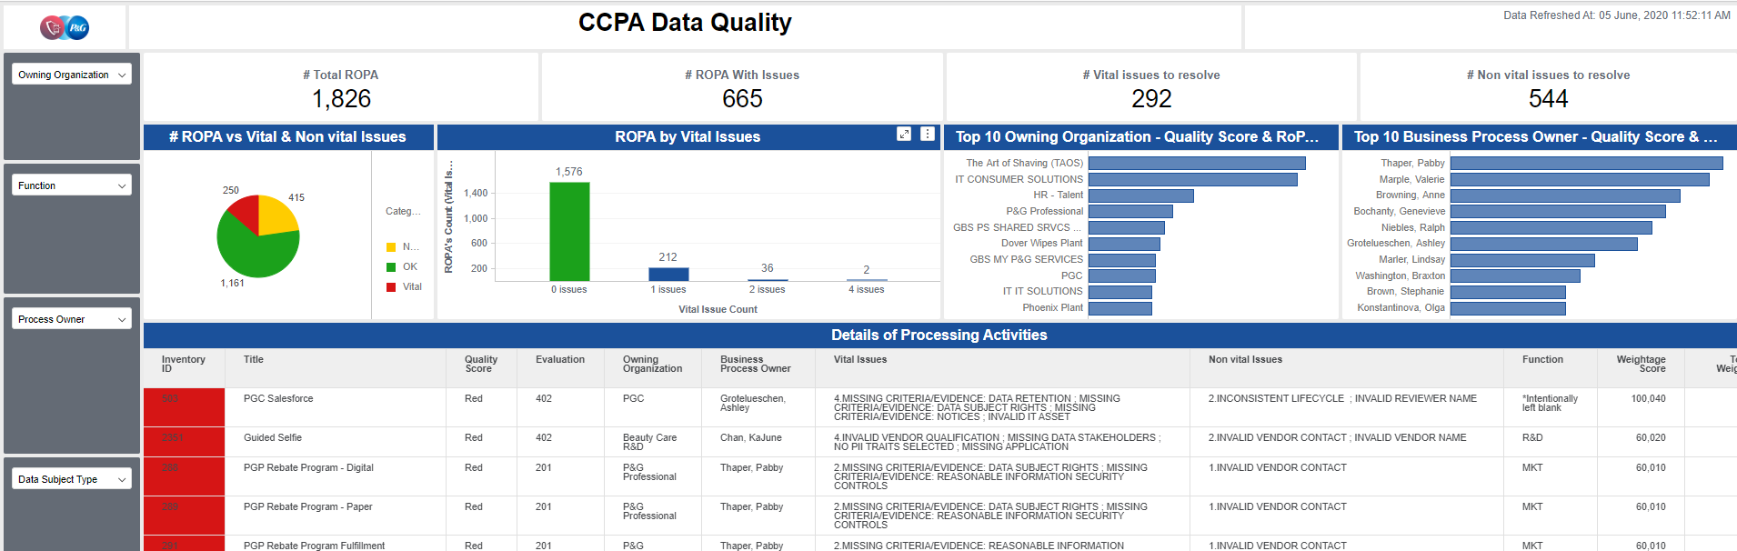
* Info Security Quality Controls (4 tabs):   
  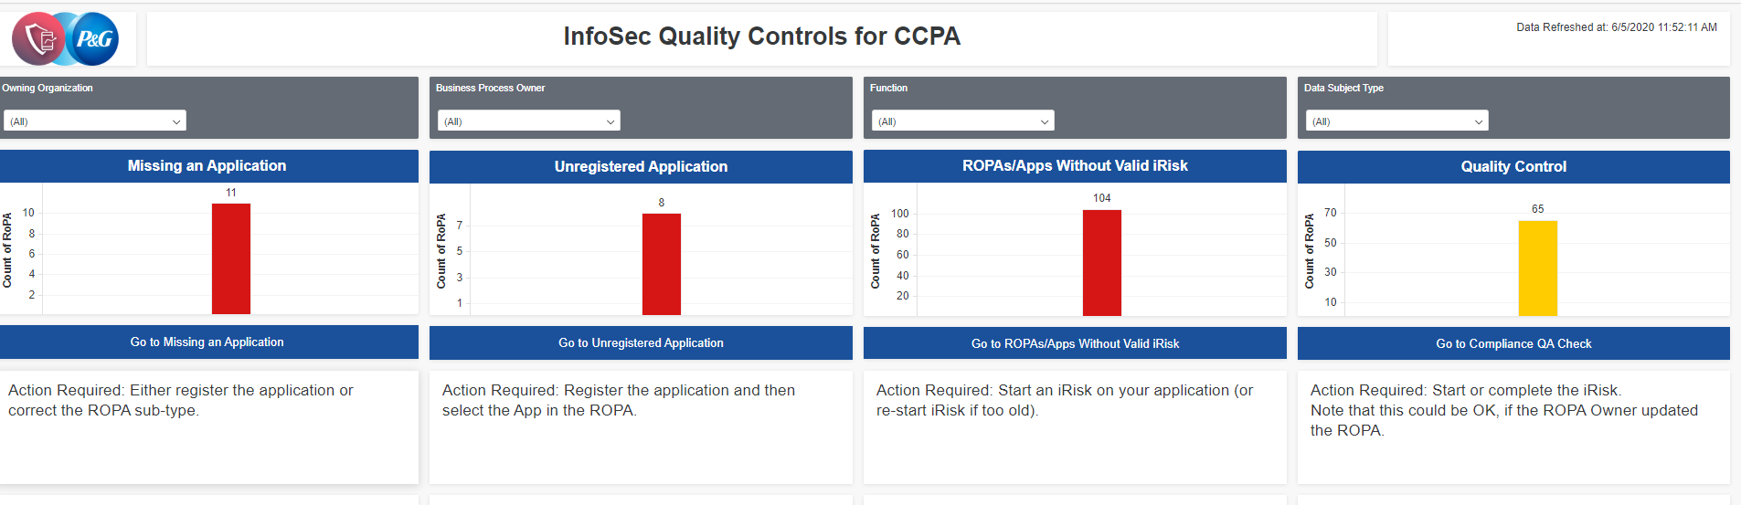

## Performance/ Data Refresh Requirements

How frequently do you need data updates (default is daily). **Daily**

Are there any existing performance baselines for the dashboard/use case? **No**

What is considered an acceptable dashboard load time? **15 seconds**

## SLAs

Reporting and Analytics service by nature does not provide SLAs at the level of business-critical processes. Please list if your use case comes with very specific requirements in terms of availability or issue resolution.

**12 hours for critical tickets, 2 working days for all others.**

## Points of Contact

List the names, titles and roles of the major participants in the development of this insight/use case. At a minimum, list the following:

* Primary Contact: Alessio Gatti
* Business Sponsor: Alan Falkingham
* Data Source System Contacts: Alessio Gatti
* Super User / UAT Testers: t.b.c.

# Process Background

## Process Description

* Refefrence to CCPA existent application

## Source Data Systems

Excel sheet within a sharepoint (will be extracted daily and uploaded to SFTP).

## Interfaces Between Source Systems

n.a.

## Existing Report References

n.a.

## Process Flow

## Data Volume

<1000 processing activities (vs CCPA = 2200 processing activities)

## Supporting Source System Screenshots

n.a.

## Source System Data Model

1 flat table

## Data Quality

Do you have perspective on existing data quality? Any known gaps? **none**

## Data Classification and other Assumptions/Limitations/Constraints

What is the most restrictive data classification level for the data to be used:

* **Business Use**

What is the most restrictive privacy risk level for the data to be used:

* **Low 🡨**
* Medium
* High

<<<< END OF UPDATES 2020-06-08 >>>>>

Please describe any other assumptions that should be made when analyzing the process data

|  |
| --- |
| Assumptions |
|  |
|  |
|  |

Please describe any other design constraints that should be made when analyzing the process data. These include any applicable government regulations, internal standards, strategic design decisions, etc.

|  |
| --- |
| Design Constraints |
|  |
|  |
|  |

# Supporting Data Model Requirements (In Cooperation with CSM and Development Team)

Please identify details about the requested data model to support the use cases requested, if you have the information at hand.

## Attributes:

Please add or include the following attributes as part of the supporting data model:

|  |  |  |  |  |
| --- | --- | --- | --- | --- |
| Label | Table | Column Element | Attribute Forms & Formats | Sort Order |
|  |  |  |  |  |
|  |  |  |  |  |
|  |  |  |  |  |
|  |  |  |  |  |

## Metrics

Please add or include the following metrics as part of the supporting data model:

|  |  |  |  |
| --- | --- | --- | --- |
| Label | Notes | Aggregation Method | Units |
|  |  |  |  |
|  |  |  |  |
|  |  |  |  |
|  |  |  |  |

## Blending Support

The implementation of the supported data model must support joining with the following existing data cubes (provide if known):

|  |  |  |
| --- | --- | --- |
| Cube Name | Describe Purpose of Blending Cubes | Field(s) on which Blend will be based |
|  |  |  |
|  |  |  |
|  |  |  |
|  |  |  |

## Data Scope

Please indicate any data filters that should be applied and expected data volume in the requested data model.

|  |
| --- |
| Data Filters |
|  |
|  |
|  |

## Data Security

Please list out any security requirements to control who within the Numerify User Base should be given permission to View the Cube or Individual Data Rows.

## Data Retention

What is the required retention time for the required supporting data model? This is usually represented as a lagging months range. For instance, a cube may support 0-12 lagging months of data which would represent records created in the current month or the 12 calendar months prior to the current calendar month.

## Dashboard Navigation

Do you have a clear vision about the number of dashboards and number of users? This might help us determine how and where to present the dashboards in our environment.

## Existing Experience and Technical Capabilities

Last but not least, in order to assess the level of consultation and technical support to be planned for, please provide some input with regards to existing capabilities in your team.

* Do you have existing experience with Numerify and in what form?
* Did you ever use formal testing processes (e.g. Panaya)?
* Do you have data modelling expertise and knowledge about the existing data sources?
* Do you have data analytics capabilities?
* Visualization Self-Service: Do you have capacity and capabilities in your team to leverage our self-service offering? Once the back-end work is done (integrations, database, metric), this could allow you to create/ change visualizations in a more agile way.